**Name: STEBIN BABU**

**Roll No: 44**

**Batch:B**

**Date: 05-05-2022**

**ADVANCED DBMS LAB**

**Experiment No.: 6**

**Aim**

To familiarize with join or cartesian product

**QUESTION**

1.Give name of customers having living city BOMBAY and branch city NAGPUR

2.Give names of customers having the same living city as their branch city

3.Give names of customers who are borrowers as well as depositors and having city

NAGPUR.

4.Give names of borrowers having deposit amount greater than 1000 and loan amount greater

than 2000.

5.Give names of depositors having the same branch as the branch of Sunil

6.Give names of borrowers having loan amount greater than the loan amount of Pramod

7.Give the name of the customer living in the city where branch of depositor Sunil is located.

8.Give branch city and living city of Pramod

9.Give branch city of Sunil and branch city of Anil

10.Give the living city of Anil and the living city of Sunil

**PROCEDURE and OUTPUT SCREEN SHOT**



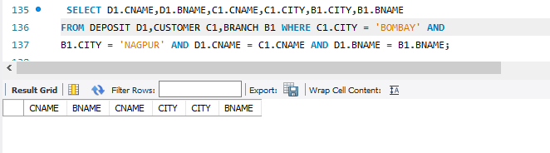

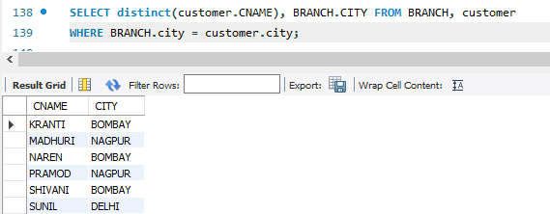



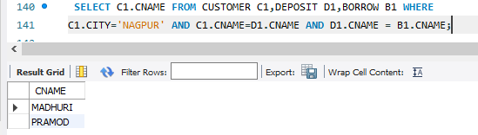

**4.**

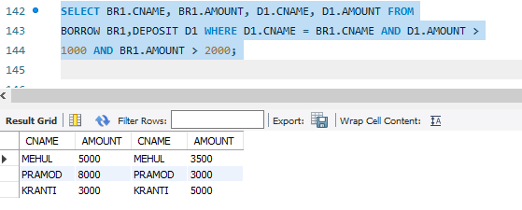

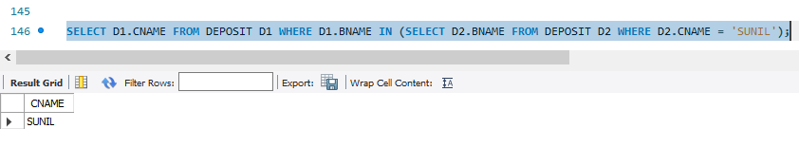**5.**

**6.**

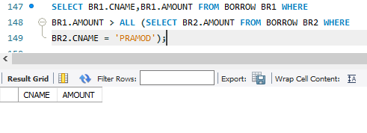

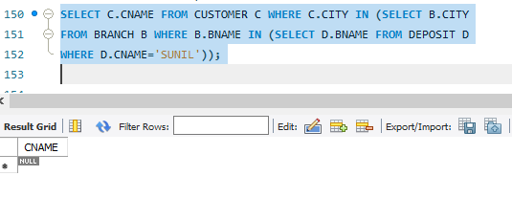**7.**

8.

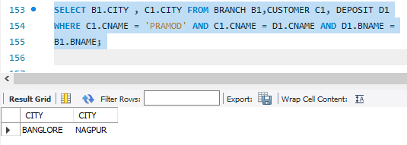

9.

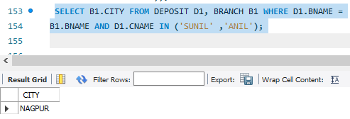

10.

